S.3
History and Political Education
Paper 1
2024
July/August
2 ¼ hours

BSR JOINT ASSESSMENT
2024

UGANDA CERTIFICATE OF EDUCATION

HISTORY AND POLITICAL EDUCATION

PAPER 1 FOR S.3

2 HOURS 15 MINUTES

INSTRUCTIONS TO CANDIDATES

- This paper consists of sections A and B. it has four examination items.
- Section A is compulsory.
- Answer one item from section B
- Answer three examination items in all.
- Any additional item answered will not be scored.
- All responses must be written in the answer booklet(s) provided.

Turn over
SECTION A
Answer all items in this section.
Scenario I
In one of the Christian seminars organised by a local church in Mbale to empower the youths, Mccoy, a guest speaker from the UK faced humiliation when a group of youths marched out of the seminar hall to protest his speech. The guest speaker had annoyed these youths when he told them to reject many African cultural practices including circumcision and dancing kadodi because they are satanic. On returning to UK, this guest speaker told his church members that he had never seen people as hostile as Ugandans that live in Mbale.
Support material
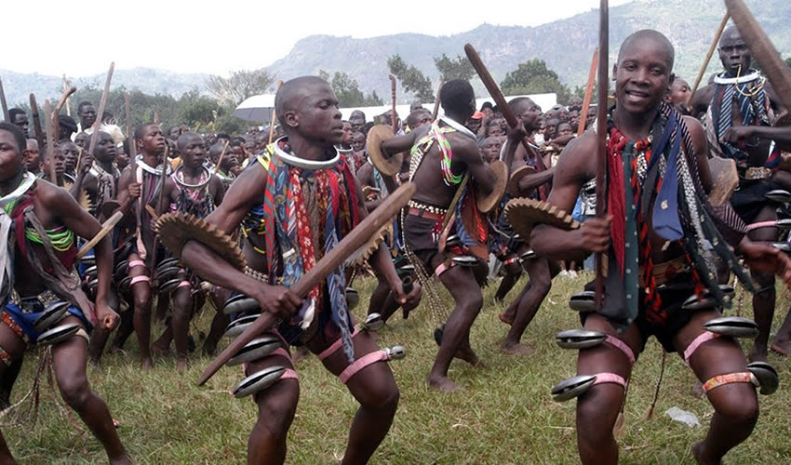
African Pearl Safaris: Imbalu circumcision
Task:
Write an essay and send it to Mccoy explaining why the youths behaved the way they did
Scenario 2
In one of the villages found in Masaka district, there are certain foreigners who have occupied almost 30% of the village. They have established a health center, hospital and school. Despite these infrastructural developments, a number of resources have been over exploited by these foreigners including land, gold, sand, water, phosphates, etc. Now the local people want to get rid of these of foreigner exploiters as a way of preserving their resources but don’t know how to do it without shedding blood. They have come to you for advice as a good student of history and political education.
Support material
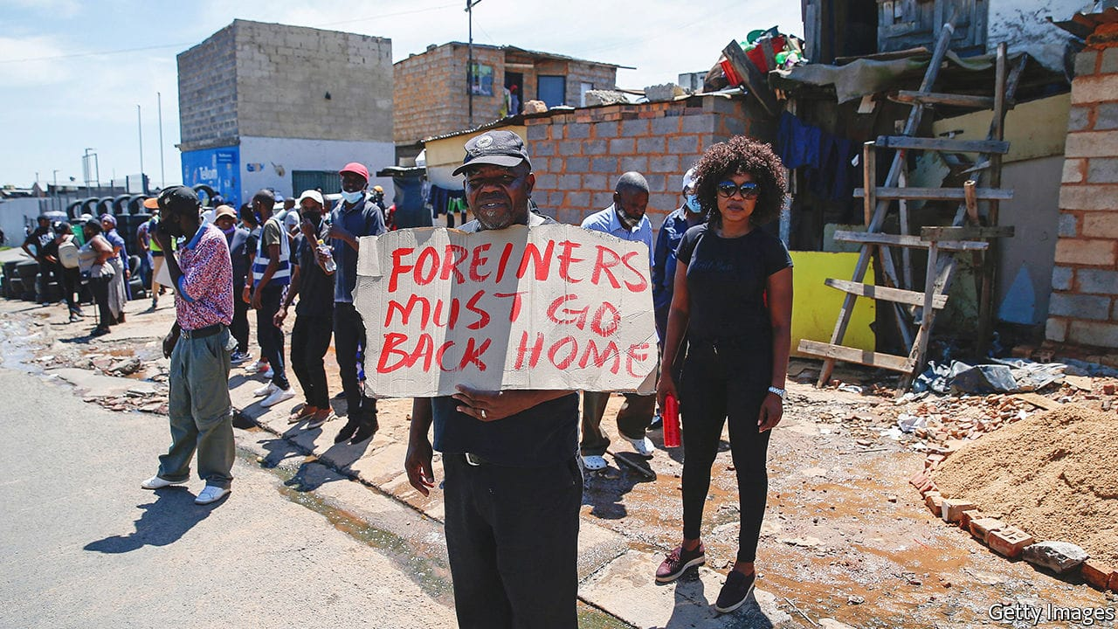
Extracted from The Economist, Jun 9th 2022
Write an essay advising the local people on what to do.
SECTION B
Answer one item from this Section
Scenario 3:
While giving a public lecture on the colonial history of Uganda at Makerere university, a visiting professor from Havard university refered to Bunyoro, Buganda, Ankole and other regions that made up Uganda as nations. Many people present in the main hall realised that he had made a mistake because these were tribes. However, the professor repeated it many times. This left the audience confused and blaming the organisers for bringing such a half-baked professor. The audience tasked the organisers to apologise for this mispresentation of Uganda’s history. Instead of apologizing, the organisers have hired you to defend the professor from Havard University.
Support material
Task: Write an essay defending the professor
Scenario 4:
In Bukusu village, there was an uprising of people with an aim to overthrow their local leaders. They blamed these leaders for their failure to provide services expected of them. The government officials organised a meeting to reconcile the local leaders of Bukusu and their people. In the meeting, the government condemned the uprising and called for calmness in the region. The government also called upon local leaders to either deliver what is expected of them or resign to pave way for others who can do the work. Unfortunately, some local leaders claimed that they don’t know what they are supposed to deliver. This worried the government that decided to organise a workshop for these local leaders to sensitise them about their roles. You are one of the speakers in this workshop
Support material
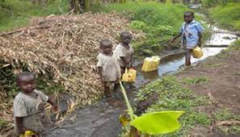
ACODE: Local government councils’ performance and public service delivery in Uganda, Kabarole District Council Score-Card Report FY 2013/2014
Task:
Write an essay of your presentation

NB: For facilitations, call 0750025446/0784114269 (BAGUMA SSENTAMU RICHARD)

